Introduction to Alternating current
What is Alternating Current?
An alternating current (AC) is defined as an electric current that changes direction and magnitude periodically. Unlike direct current (DC), which flows in one direction, AC transmits power over long distances with less energy loss. Most household appliances use AC when plugged into a wall socket.

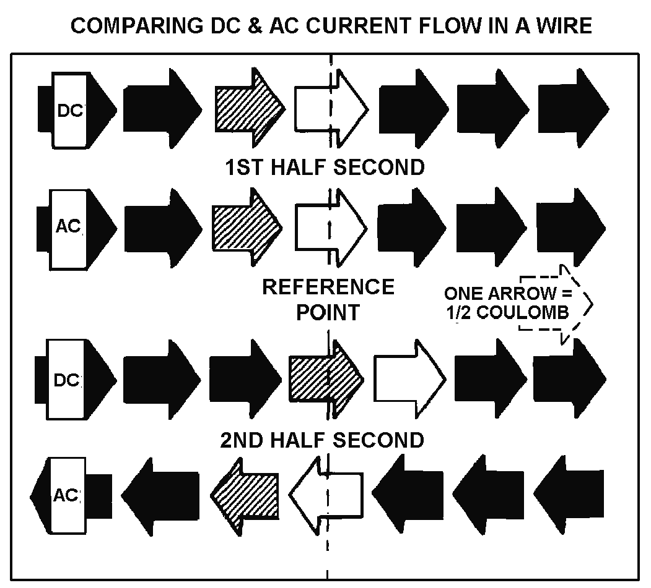
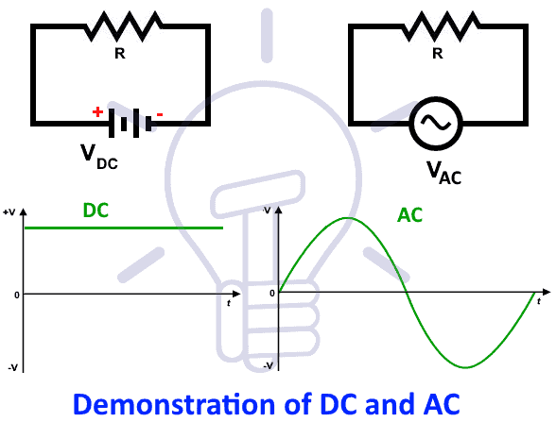

The shape of the AC waveform can vary depending on the source and the load. The most common waveform is a sine wave, which has a smooth and symmetrical shape. Other waveforms include square waves, triangular waves, and sawtooth waves, which have different characteristics and applications.

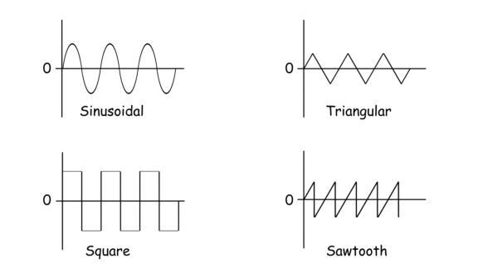

Basic principle of generating ac current

The basic principle of generating AC current is Faraday's Law of Electromagnetic Induction, which states that a changing magnetic field within a conductor induces an electromotive force (EMF) or voltage, driving an electric current.
Electric Generator
A generator is a mechanical device that converts mechanical energy into electrical energy. The electricity generated at various power plants is produced by the generators installed there. When a coil spins in a magnetic field or moves relative to a magnet, it generates an electromotive force (emf) or potential difference.
AC Generator
A machine that transforms mechanical energy into electrical energy is known as an AC generator. Mechanical energy is supplied to the AC Generator through steam turbines, gas turbines, and combustion engines. Alternating electrical power in the form of alternating voltage and current is the output.

Components of A.C Generator

1. Field magnet
It is a permanent magnet of the horse shoe shape in a small dynamo (magneto) or it is a powerful electromagnet in a large dynamo. It produces a strong magnetic field in the region between its pole-pieces.

2. Armature
It consists of a rectangular coil ABCD having a large number of turns of insulated copper wire wound on a soft iron cylindrical core. The core is laminated one to avoid losses due to Eddy Currents. The soft iron core concentrates the lines of force to increase the flux

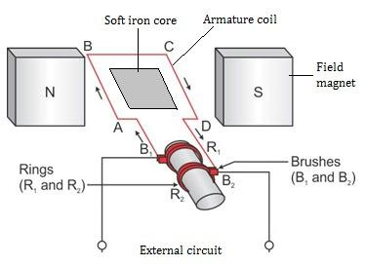

density B. The armature can be rotated in the magnetic field pf the field magnet about an axis perpendicular to field B.

3.Slip rings
The two ends of the armature coil are connected to two coaxial brass rings R1 and R2 called slip rings. The rings are rigidly fixed to same shaft which is used to rotate the coil. The slips are insulated from each other as well as form the shaft. As the armature coil rotates, the slip rings also rotate about the same axis of rotation.

4. Brushes
Two graphite or flexible metallic rods called brushes are lightly presses against the two slip rings. The brushes B1 and B2 remains fixed in their positions and maintain sliding contacts with the rotatable slip rings R1 and R2 respectively. It is through these brushes that the current induced in the armature coil is fed to the external circuit by means of line wires.

5. Source of energy
The armature coil is rotated about its axis with the help of turbine or any other device connected to it. It is the rotational kinetic energy of the turbine which is ultimately converted into electrical energy by the a.c generator.

Working of A.C Generator
Refer above diagram for better understanding!
1. As the armature coil rotates, the magnetic flux linked with it changes and so an induced current flows through it. Suppose initially the coil ABCD be in the vertical position and it is rotated in the clockwise direction.
2. The side AB moves downward and DC moves upward. According to Fleming's right hand rule., the induced current flows in the direction DCAB, with brush B1 acting as positive terminal and brush B2 as negative terminal. During the second half-rotation, the side AB moves upward and DC moves downward.
3. The direction of induced current is reversed , i.e., it flows along ABCD, so that the brush B2 now function as the positive terminal and brush B1 as the negative terminal. Thus the direction of current int he external circuit is reversed after every half cycle.
4. Hence alternating current is produced by the generator. Such a generator which generates alternating current is called an a.c generator or an alternator.

Advantages of AC Generators over DC Generators
- Through transformers, AC generators may be simply stepped up and down.
- Because of the step-up functionality, the transmission link size in AC Generators is less.
- The losses in AC generators are lower than in DC machines.
- An AC generator is much smaller than a DC generator

Representation of ac current and voltage
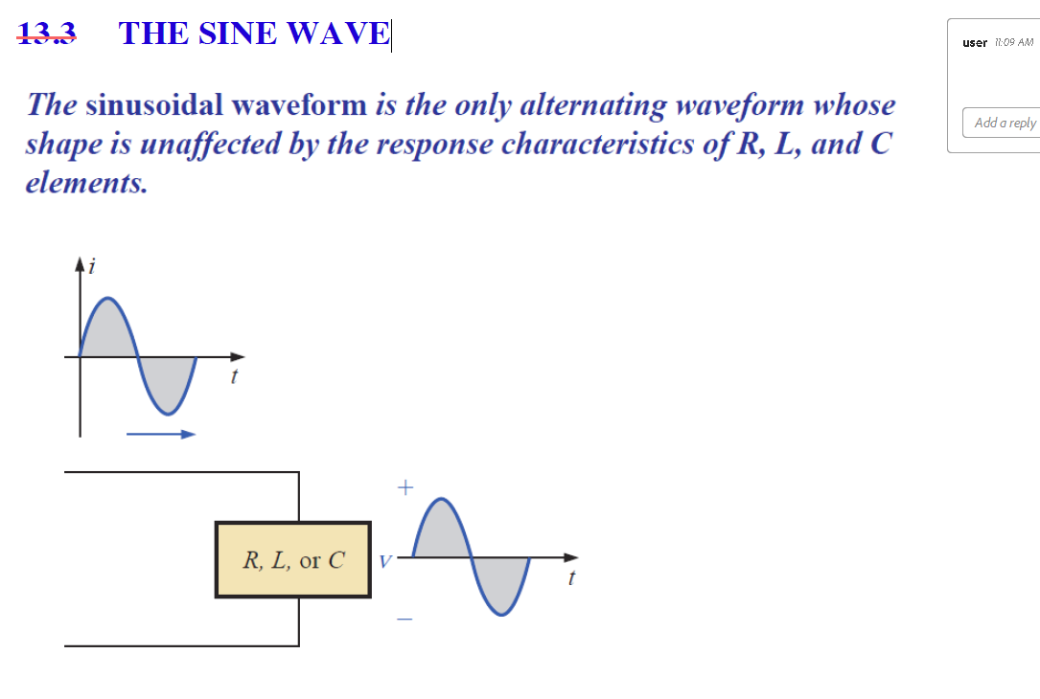

- Waveform:
The waveform is a graph of magnitude of an AC quantity against time. The waveform tells us about instantaneous (instant to instant) change in the magnitude (value) of an AC waveform.
- Instantaneous value:
The instantaneous value of an ac quantity is defined as the value of that quantity at particular instant of time.

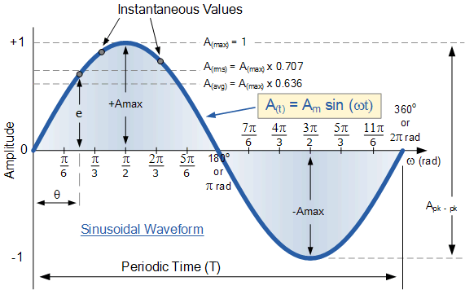

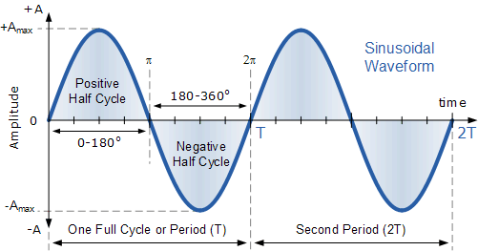

- Time Period or Periodic Time (T):
Time period (T) is defined as the time taken in seconds by the waveform of an ac quantity to complete one cycle. After every T seconds, the cycle repeats itself as shown in fig.(b).
- Frequency:
Frequency is defined as the number of cycles completed by an alternating quantity in one second. It is denoted by “f” and its units are cycles/second or Hertz (Hz).

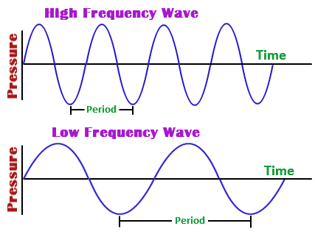

- Amplitude:
The maximum value or peak value of an ac quantity is called as its amplitude. The amplitude is denoted by V_{m} for voltage, I_{m} for current waveform etc.
- . Angular Velocity (ω):
The angular velocity (ω) is the rate of change of angle ωt with respect to time.
∴ ω = dθ/dt ……(1)

where dθ is the change in angle in time dt.
If dt = T i.e. time period, (one cycle) then the corresponding change in θ is 2 π radians.
∴ dθ = 2π
∴ ω = 2π/T …..(2)

But 1/T = f
∴ ω = 2πf
- Peak and Peak to Peak Voltage

- Peak to peak values are most often used when measuring the magnitude on the cathode ray oscilloscope (CRO) which is a measuring instrument.
- Peak voltage is the voltage measured from baseline of an ac waveform to its maximum or peak level. It is also called as amplitude.
- Peak voltage is denoted by V_{m} or V_{p}.
- Peak to peak voltage is the voltage measured from the maximum positive level to maximum negative level.
- Peak to peak voltage is denoted by V_{p-p}.
∴ V_{p-p} = 2 V_{m}
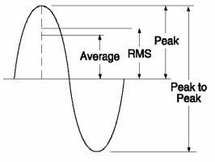

Fig. 1: Peak and peak to peak value

- Effective or R.M.S. Value
- The effective or RMS value of an ac current is equal to the steady state or DC current that is required to produce the same amount of heat as produced by the ac current provided that the resistance and time for which these currents flow are identical.
- RMS value of ac current is denoted by I_{rms} and RMS voltage is denoted by V_{rms}.
- RMS value of a sinusoidal waveform is equal to 0.707 times its peak value.
I_{rms} = 0.707 I_{m}
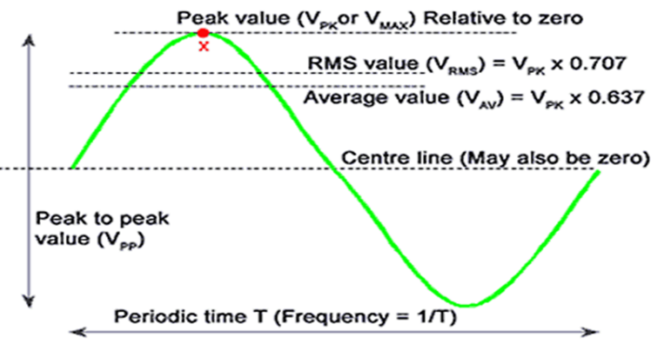

- The average value of an alternating quantity is equal to the average of all, the instantaneous values over a period of half cycle.
- The average value of ac current denoted by I_{av} or I_{dc}.
- The average value of a sinusoidal waveform is 0.637 times its peak value as shown in fig.1.
I_{av} = I_{dc} = 0.637 I_{m}

- Form factor
- The form factor of an alternating quantity is defined as the ratio of its RMS value to its average value.
∴ Form factor $= \frac{I_{rms}}{I_{av}}$
Form factor is dimensionless quantity and its value is always higher than one.

- Peak factor

- The maximum value (peak value or amplitude) of an alternating quantity is called as the crest value of the quantity.
- The crest factor is defined as the ratio of the crest value to the rms value of the quantity.

Peak factor = $\frac{Peak value}{rms value}$
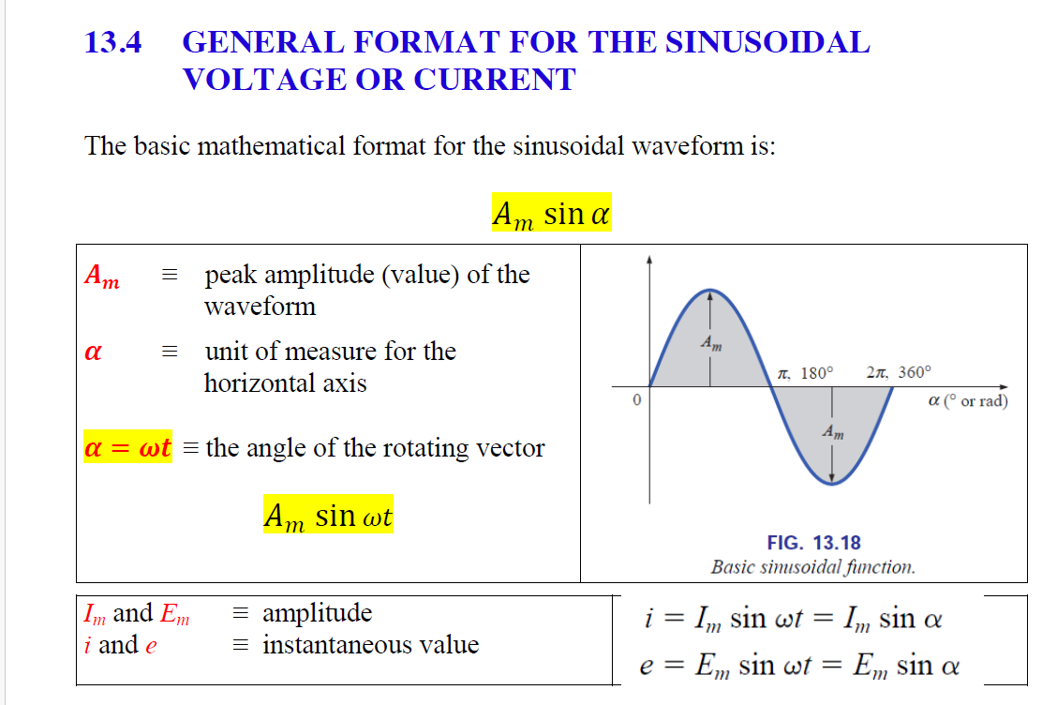

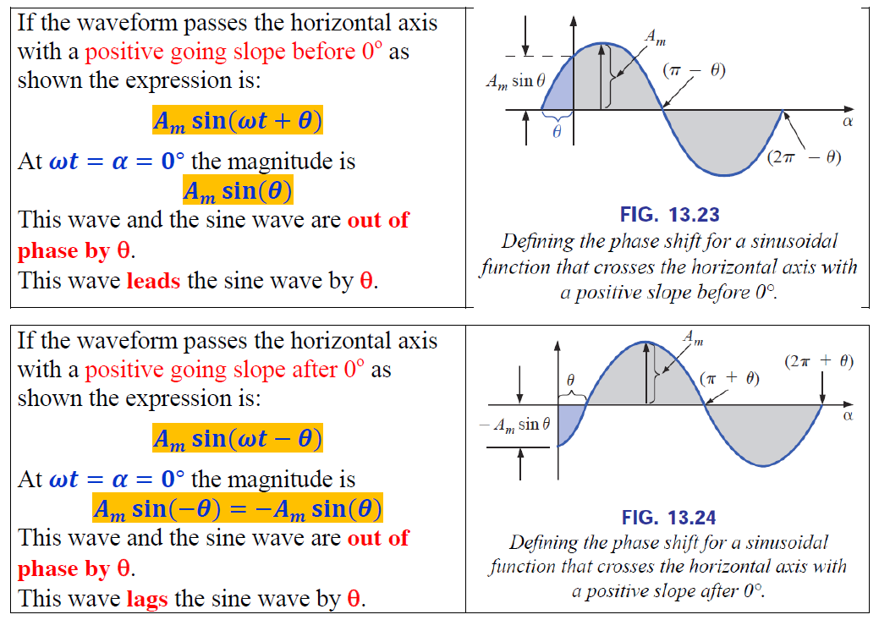

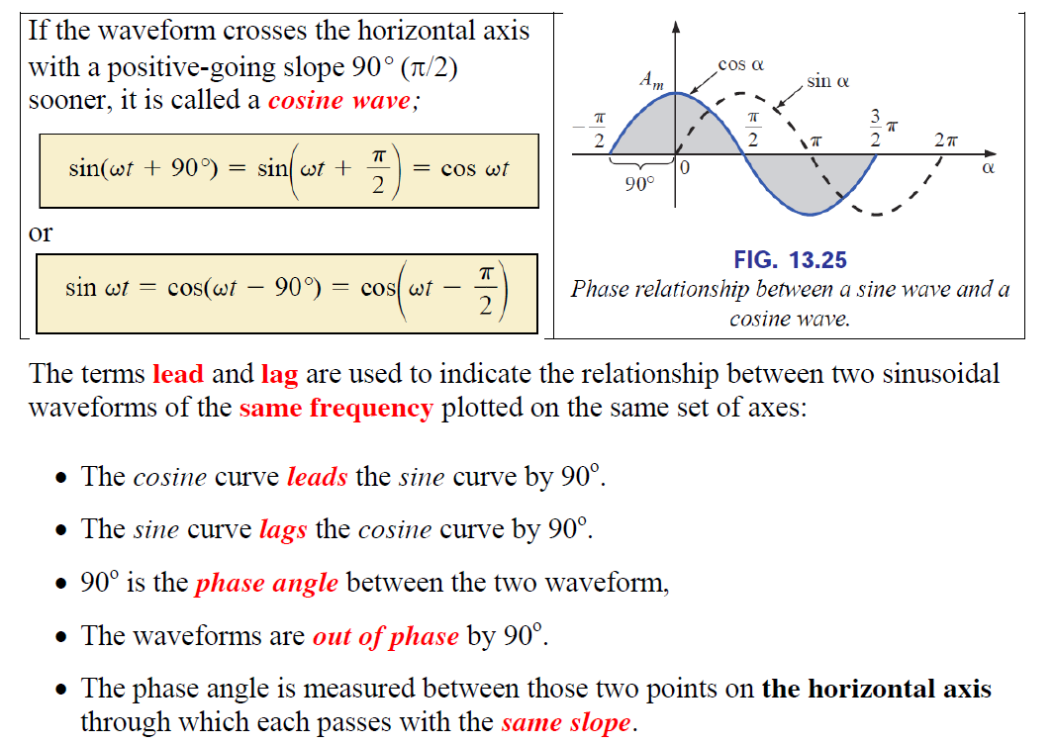

Purely resistive circuit

The circuit containing only a pure resistance of R ohms in the AC circuit is known as Pure Resistive AC Circuit. The presence of inductance and capacitance does not exist in a purely resistive circuit. The alternating current and voltage both move forward as well as backwards in both the direction of the circuit. Hence, the alternating current and voltage follows a shape of the Sine wave or known as the sinusoidal waveform.

In an AC circuit, the ratio of voltage to current depends upon the supply frequency, phase angle, and phase difference. In an AC resistive circuit, the value of resistance of the resistor will be same irrespective of the supply frequency.
Let the alternating voltage applied across the circuit be given by the equation
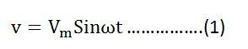
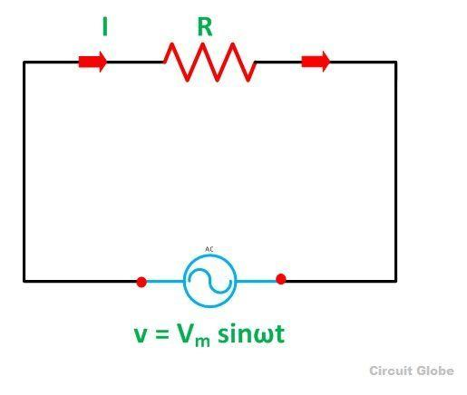
Then the instantaneous value of current flowing through the resistor shown in the figure below will be:
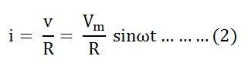

The value of current will be maximum when ωt= 90° or sinωt = 1
Putting the value of sinωt in equation (2) we will get
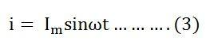

Phase Angle and Waveform of Resistive Circuit
From equation (1) and (3), it is clear that there is no phase difference between the applied voltage and the current flowing through a purely resistive circuit, i.e. phase angle between voltage and current is zero. Hence, in an AC circuit containing pure resistance, the current is in phase with the voltage as shown in the waveform figure below.
Waveform and Phasor Diagram of Pure Resistive Circuit
Power in Pure Resistive Circuit
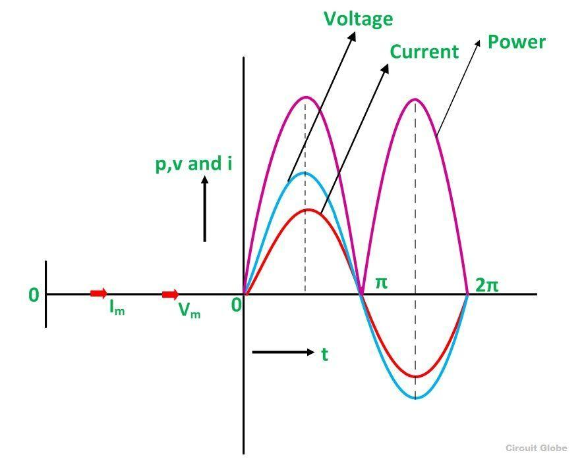
The three colours red, blue and pink shown in the power curve or the waveform indicate the curve for current, voltage and power respectively. From the phasor diagram, it is clear that the current and voltage are in phase with each other that means the value of current and voltage attains its peak at the same instant of time, and the power curve is always positive for all the values of current and voltage.

Pure inductive Circuit
The circuit which contains only inductance (L) and not any other quantities like resistance and capacitance in the circuit is called a Pure inductive circuit.
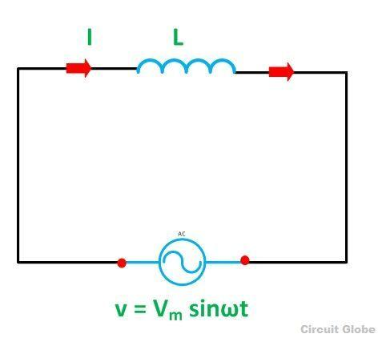
The circuit containing pure inductance is shown below:

Circuit Diagram of pure Inductive Circuit

Let the alternating voltage applied to the circuit is given by the equation:
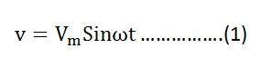
As a result, an alternating current i flows through the inductance which induces an emf in it. The equation is shown below:
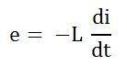
The emf which is induced in the circuit is equal and opposite to the applied voltage. Hence, the equation becomes,
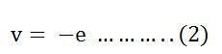

Putting the value of e in equation (2) we will get the equation as
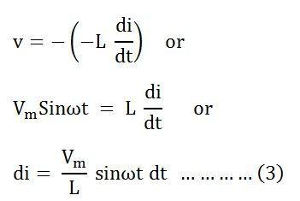
Integrating both sides of the equation (3), we will get
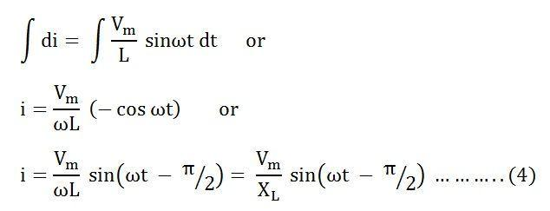where, X_{L} = ω L is the opposition offered to the flow of alternating current by a pure inductance and is called inductive reactance.
The value of current will be maximum when sin (ωt – π/2) = 1
Therefore,
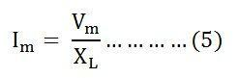
Substituting this value in I_{m} from the equation (5) and putting it in equation (4) we will get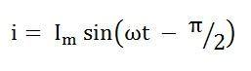

Phasor Diagram and Power Curve of Inductive Circuit
The current in the pure inductive AC circuit lags the voltage by 90 degrees. The waveform, power curve and phasor diagram of a purely inductive circuit is shown below
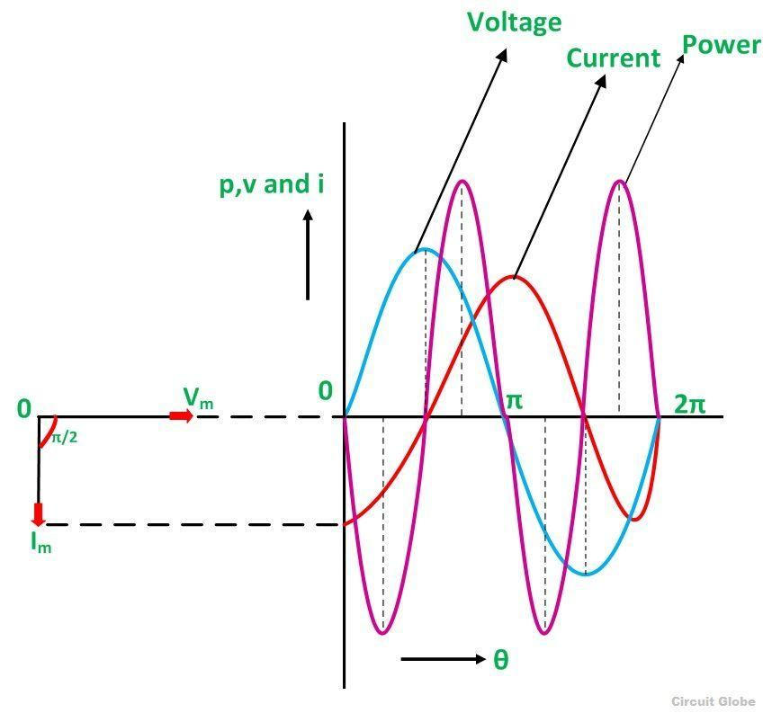Phasor Diagram and Waveform of Pure Inductive Circuit
The voltage, current and power waveform are shown in blue, red and pink colours respectively. When the values of voltage and current are at its peak as a positive value, the power is also positive and similarly, when the voltage and current give negative waveform the power will also become negative. This is because of the phase difference between voltage and current.
When the voltage drops, the value of the current changes. When the value of current is at its maximum or peak value of the voltage at that instance of time will be zero, and therefore, the voltage and current are out of phase with each other by an angle of 90 degrees.
The phasor diagram is also shown on the left-hand side of the waveform where current (I_{m}) lag voltage (V_{m}) by an angle of π/2.

Power in Pure Inductive Circuit
Instantaneous power in the inductive circuit is given by
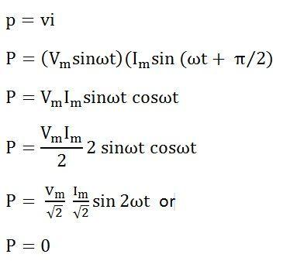
Hence, the average power consumed in a purely inductive circuit is zero.
The average power in one alteration, i.e., in a half cycle is zero, as the negative and positive loop is under power curve is the same.
In the purely inductive circuit, during the first quarter cycle, the power supplied by the source, is stored in the magnetic field set up around the coil. In the next quarter cycle, the magnetic field diminishes and the power that was stored in the first quarter cycle is returned to the source.
This process continues in every cycle, and thus, no power is consumed in the circuit.

Pure Capacitor Circuit
The circuit containing only a pure capacitor of capacitance C farads is known as a Pure Capacitor Circuit. The capacitors stores electrical power in the electric field, their effect is known as the capacitance.
A capacitor consists of two insulating plates which are separated by a dielectric medium. It stores energy in electrical form. The capacitor works as a storage device, and it gets charged when the supply in ON and gets discharged when the supply is OFF. If it is connected to the direct supply, it gets charged equal to the value of the applied voltage.
Circuit Diagram of pure Capacitor Circuit

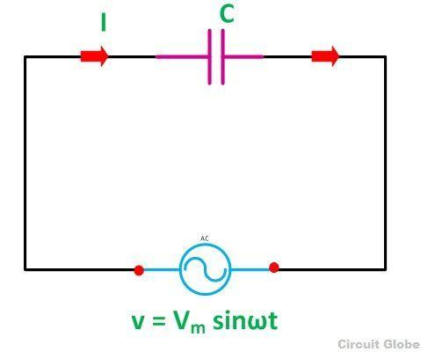

Let the alternating voltage applied to the circuit is given by the equation: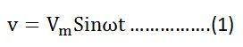
Charge of the capacitor at any instant of time is given as: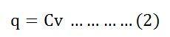
Current flowing through the circuit is given by the equation: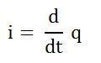
Putting the value of q from the equation (2) in equation (3) we will get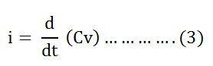
Now, putting the value of v from the equation (1) in the equation (3) we will get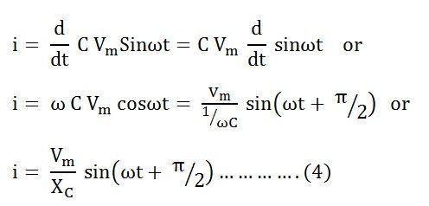
Where Xc = 1/ωC is the opposition offered to the flow of alternating current by a pure capacitor and is called Capacitive Reactance.
The value of current will be maximum when sin(ωt + π/2) = 1. Therefore, the value of maximum current I_{m} will be given as: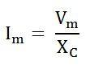
Substituting the value of I_{m} in the equation (4) we will get: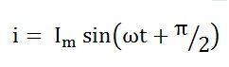

In the pure capacitor circuit, the current flowing through the capacitor leads the voltage by an angle of 90 degrees. The phasor diagram and the waveform of voltage, current and power are shown below:
Phasor Diagram and Waveform of Pure Capacitor Circuit

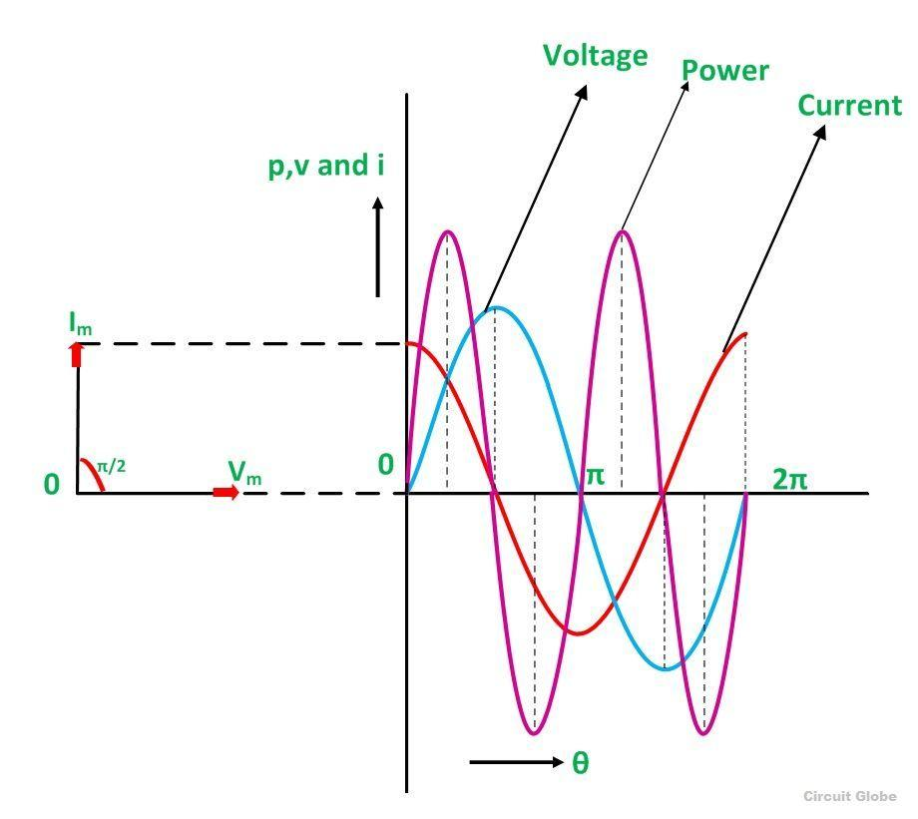

The red colour shows current, blue colour is for voltage curve, and the pink colour indicates a power curve in the above waveform.
When the voltage is increased, the capacitor gets charged and reaches or attains its maximum value and, therefore, a positive half cycle is obtained. Further when the voltage level decreases the capacitor gets discharged, and the negative half cycle is formed.
If you examine the curve carefully, you will notice that when the voltage attains its maximum value, the value of the current is zero that means there is no flow of current at that time.
When the value of voltage is decreased and reaches a value π, the value of voltage starts getting negative, and the current attains its peak value. As a result, the capacitor starts discharging. This cycle of charging and discharging of the capacitor continues.
The values of voltageasz and current are not maximised at the same time because of the phase difference as they are out of phase with each other by an angle of 90 degrees.
The phasor diagram is also shown in the waveform indicating that the current (I_{m}) leads the voltage (V_{m}) by an angle of π/2.

Power in Pure Capacitor Circuit
Instantaneous power is given = vi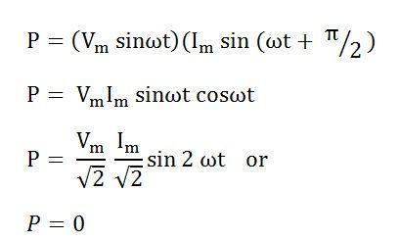
Hence, from the above equation, it is clear that the average power in the capacitive circuit is zero.
The average power in a half cycle is zero as the positive and negative loop area in the waveform shown are same.
In the first quarter cycle, the power which is supplied by the source is stored in the electric field set up between the capacitor plates. In the another or next quarter cycle, the electric field diminishes, and thus the power stored in the field is returned to the source. This process is repeated continuously and, therefore, no power is consumed by the capacitor circuit.

